Department of Electrical and Computer Engineering
North South University

Senior Design Project
YOUR PROJECT TITLE

STUDENT NAME1 ID# 1
STUDENT NAME2 ID# 2
STUDENT NAME3 ID# 3
STUDENT NAME4 ID# 4

Faculty Advisor:
Dr. Riasat Khan
Assistant Professor
ECE Department

Spring, 2023

APPROVAL
Student Name1 (ID # 15), Student Name2 (ID # 15) and Student Name3 (ID # 15) from Electrical and Computer Engineering Department of North South University, have worked on the Senior Design Project titled “Write your CSE/EEE499 Capstone Project Title/Name HERE” under the supervision of Dr. Riasat Khan partial fulfillment of the requirement for the degree of Bachelors of Science in Engineering and has been accepted as satisfactory.

Supervisor’s Signature

…………………………………….
Dr. Riasat Khan
Assistant Professor
Department of Electrical and Computer Engineering
North South University
Dhaka, Bangladesh.

Chairman’s Signature

…………………………………….
Dr. Rajesh Palit
Professor
Department of Electrical and Computer Engineering
North South University
Dhaka, Bangladesh.

DECLARATION

This is to declare that this project is our original work. No part of this work has been submitted elsewhere partially or fully for the award of any other degree or diploma. All project related information will remain confidential and shall not be disclosed without the formal consent of the project supervisor. Relevant previous works presented in this report have been properly acknowledged and cited. The plagiarism policy, as stated by the supervisor, has been maintained.

Students’ names & Signatures

1. Student Name1

_ _ _ _ _ _ _ _ _ _ _ _ _ _ _ _ _
2. Student Name2

_ _ _ _ _ _ _ _ _ _ _ _ _ _ _ _ _
3. Student Name3

_ _ _ _ _ _ _ _ _ _ _ _ _ _ _ _ _

ACKNOWLEDGEMENTS

The authors would like to express their heartfelt gratitude towards their project and research supervisor, Dr. Riasat Khan, Assistant Professor, Department of Electrical and Computer Engineering, North South University, Bangladesh, for his invaluable support, precise guidance and advice pertaining to the experiments, research and theoretical studies carried out during the course of the current project and also in the preparation of the current report.
Furthermore, the authors would like to thank the Department of Electrical and Computer Engineering, North South University, Bangladesh for facilitating the research. We would also like to thank my friends X, Y, and Z for helping us in this project. The authors would also like to thank their loved ones for their countless sacrifices and continual support.

ABSTRACT
Write your CSE/EEE499 Capstone Project Title/Name

Start your Abstract here. All papers must include an abstract. Abstract should contain the main work of the project in concise paragraph(s). Do not cite references or use abbreviations in the abstract. Abstract will be copied and included in the conference proceedings or journal’s webpage or department website. You should use Times New Roman Font with 12 Font size. You should use Justify Paragraph option. You should use 1.5 Line Spacing. Do not use References, Symbols, Special Characters, Footnotes, or Math equations in the Abstract. Write few sentences from each of the following: introducing the topic, current status, methods followed, results acquired and impact/significance of the result.

TABLE OF CONTENTS
LETTER OF TRANSMITTAL Error! Bookmark not defined.
APPROVAL 2
DECLARATION 3
ACKNOWLEDGEMENTS 4
ABSTRACT 5
LIST OF FIGURES 8
LIST OF TABLES 9
Chapter 1 Introduction 10
1.1 Background and Motivation 10
1.2 Purpose and Goal of the Project 10
1.3 Organization of the Report 10
Chapter 2 Research Literature Review 11
2.1 Existing Research and Limitations 11
Chapter 3 Methodology 12
3.1 System Design 12
3.2 Hardware and/or Software Components 12
3.3 Hardware and/or Software Implementation 12
Chapter 4 Investigation/Experiment, Result, Analysis and Discussion 13
Chapter 5 Impacts of the Project 14
5.1 Impact of this project on societal, health, safety, legal and cultural issues 14
5.2 Impact of this project on environment and sustainability 14
Chapter 6 Project Planning and Budget 15
Chapter 7 Complex Engineering Problems and Activities 16
7.1 Complex Engineering Problems (CEP) 16
7.2 Complex Engineering Activities (CEA) 16
Chapter 8 Conclusions 18
8.1 Summary 18
8.2 Limitations 18
8.3 Future Improvement 18
References 19

LIST OF FIGURES
Figure 1. A sample Gantt chart. 15Figure 2. A sample budget table. 15

LIST OF TABLES
TABLE I. A SAMPLE SOFTWARE/HARDWARE TOOLS TABLE 14
TABLE II. A SAMPLE COMPLEX ENGINEERING PROBLEM ATTRIBUTES TABLE 18
TABLE III. A SAMPLE COMPLEX ENGINEERING PROBLEM ACTIVITES TABLE 19

Chapter 1 Introduction

Background and Motivation
[Describe the background and motivation of the project. For an automatic depression prediction project, the students can write about depression, various types of depression, the consequences of depression, relevant facts about depression with statistics, etc. with proper references and relevant figures. Students can write why depression should be diagnosed early [1] (project motivation). The references can be cited in IEEE format.]

Purpose and Goal of the Project
[Describe the objective of the project. Students can write the contributions of the project and explicitly mention their novelty.]

Organization of the Report
[Describe the arrangement of different sections of the report. For example, Chapter 2 presents the literature reviews related to this project.]

Chapter 2 Research Literature Review

2.1 Existing Research and Limitations
[Briefly discuss some of the recent articles related to this research. For example, “Valverde et al. [2] developed a transfer learning-based CNN model for automatic glaucoma classification. The authors used color fundus images from DRISHTI-GS and RIM-ONE datasets. They preprocessed the images and applied five CNN models with transfer learning techniques. Among these, the VGG-19 model showed the best result with an AUC of 94% with a sensitivity and specificity score of 87.01% and 89.01%, respectively.”]
[Discuss the research limitations in the existing articles. For example, “The following observations have been made after a detailed examination of the literature reviews − (i) most of the articles employed an individual open-source or custom Bangla sign language dataset of small size, (ii) in general, the articles did not utilize multiple deep learning techniques and compared their performances, and (iii) there is an absence of deploying the sign language detection into an embedded device for real-time analysis. These investigations have motivated us to implement a Bangla sign language detection system in this paper using combined open-source and custom datasets and apply three deep learning approaches (Detectron2, EfficientDet-D0, and YOLOv7). Finally, the YOLOv7 Tiny has been implemented in a Jetson Nano edge device for real-time Bangla sign language recognition.”]

Chapter 3 Methodology

3.1 System Design
[Describe the project’s design via flowchart, block diagram(s), schematics, database design, UML diagram, etc.]

3.2 Hardware and/or Software Components
[Describe the utilized software and hardware components to implement the project. For example, for an AI-related project, students can write about the dataset, EDA, preprocessing techniques, applied AI/ML/DL models, feature selection, hyperparameter optimization techniques, etc. For a hardware project, students can write about various individual components/modules/sensors, used microcontrollers, communication techniques, etc. For a software project, students can write about the developed front-end and back-end designs, employed data management tools, security techniques, etc. Students can add a similar table on employed software and/or hardware tools below:]
TABLE I. A SAMPLE SOFTWARE/HARDWARE TOOLS TABLE
Tool | Functions | Other similar Tools (if any) | Why selected this tool

3.3 Hardware and/or Software Implementation
[Briefly describe the implementation of the hardware that may include PCB design, assembly of the components, etc. or the implementation of the software modules that may include modeling, simulations, application development, etc.]

Chapter 4 Investigation/Experiment, Result, Analysis and Discussion
[Describe the experiments performed addressing all the variables, various results of the project with appropriate figures, tables and texts. The tables and figures should contain appropriate brief captions. Figures should contain appropriate axis labels and legends. The tables and figures should be cited in the project. Perform in-depth analyses of the results represented by each of the figures and tables and finally perform a constructive discussion on the outcome.]

Chapter 5 Impacts of the Project

5.1 Impact of this project on societal, health, safety, legal and cultural issues
[Describe the impact of the project on societal, health, safety, legal and cultural issues. An example of an automatic depression prediction project carries significant health and societal implications as it contributes to the early detection of depression and helps prevent associated social issues, such as suicidal behavior. Similarly, a sign language detection project holds notable societal impact as it serves to support the deaf community, enhancing their quality of life through improved access to quality education, increased employment opportunities, and a reduction in inequality.]

5.2 Impact of this project on environment and sustainability
[Describe the impact of the project on the environment and sustainability. An example of a hardware-based project focused on air quality monitoring has significant implications for environmental impact as it aids in the collection of air quality data and the calculation of the air quality index (AQI). On the other hand, a software-based project aimed at automatic pollution detection holds both environmental and ecological significance as it involves the automated identification of waste materials and contributes to the cleanup of the surrounding environment. These projects demonstrate the potential of technology to address and mitigate environmental challenges and promote sustainability.]

Chapter 6 Project Planning and Budget
[Describe the planning of the project with Gantt and/or RACI chart. A sample Gantt chart is given below.]
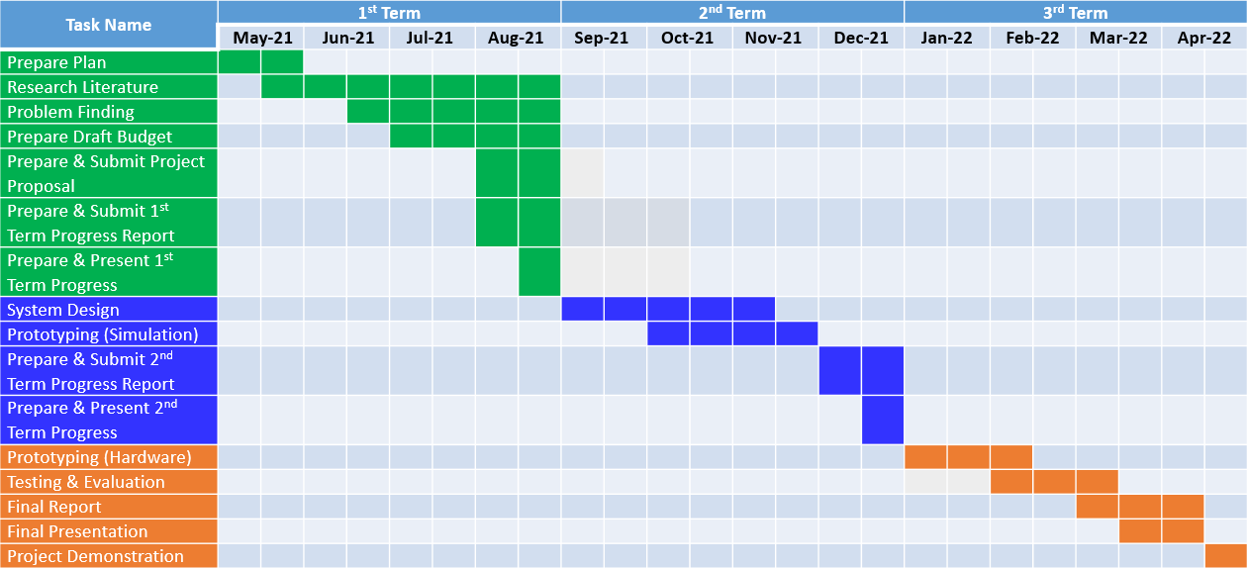
Figure 1. A sample Gantt chart.
[Describe the budget of the project with approximate cost of individual components and the entire design. A sample budget of the project is given below.]
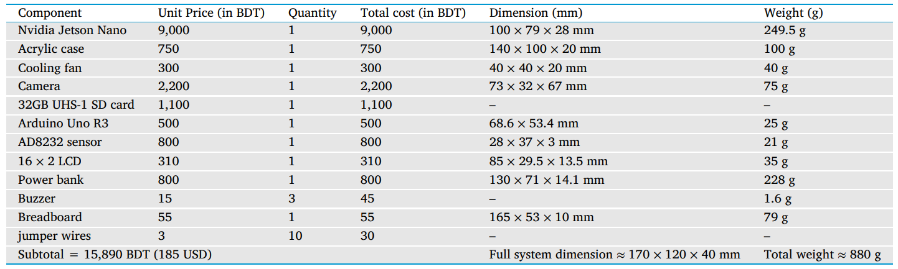
Figure 2. A sample budget table.

Chapter 7 Complex Engineering Problems and Activities

7.1 Complex Engineering Problems (CEP)
[Describe the Complex Engineering Problems (CEP) attributes related to this project. Discuss with your capstone project supervisor regarding the table. A sample table is given below.]
TABLE II. A SAMPLE COMPLEX ENGINEERING PROBLEM ATTRIBUTES TABLE
Attributes |  | Addressing the complex engineering problems (P) in the project
P1 | Depth of knowledge required (K3-K8) | The project requires knowledge of Electrical Circuits, Electronics (K3), Wireless Communication, Embedded System, Sensors and Instrumentations (K4), Designing and Simulation (K5), Engineering & IT (Circuit Design/Smartphone Application) Tools (K6), Involve Environmental Effects (K7), Scientific Research Papers (WK8).
P2 | Range of conflicting requirements | In the prototype, the strength of the structure (mass) and capability of weightlifting (# of sensors) is directly related to the capacity of the motors.
P3 | Depth of analysis required | No unique way to design. Depth of analysis needed to select a specific solution from many alternatives. (Static/mobile/drone. Various microcontrollers. Various sensors)
P4 | Familiarity of issues | Various air quality sensors, Raspberry Pi/Arduino Mega/Nano/Uno/NodeMCU Microcontroller.
P5 | Extent of applicable codes | There is no existing code or standard for this project.
P6 | Extent of stakeholder involvement | There are several stakeholders needs to be involved including the owner of the device, installing places, Ministry of Environment, etc.
P7 | Interdependence | Project involves a number of interdependent sub-systems such as microcontrollers, sensors, wireless communication system, circuit designing tools, mobile apps.

Table I demonstrates a sample complex engineering problem attribute.

7.2 Complex Engineering Activities (CEA)
[Describe the Complex Engineering Activities (CEA) related to this project. Discuss with your capstone project supervisor regarding the table. A sample table is given below.]
TABLE III. A SAMPLE COMPLEX ENGINEERING PROBLEM ACTIVITIES TABLE
Attributes |  | Addressing the complex engineering activities (A) in the project
A1 | Range of resources | This project involves human resource, money, modern tools (simulation software/mobile APP), hardware components, etc.
A2 | Level of interactions | Involves interactions between different stakeholders including group members to design the device, installing places, Ministry of Environment to collect data, etc.
A3 | Innovation | Employs innovative skills of engineering by introducing technology in a different manner in the environment and IoT sector
A4 | Consequences to society  / Environment | Impact in our environment since it helps to monitors the air quality data and measure AQI
A5 | Familiarity | Needs to be familiar with the various sensors, microcontrollers, wireless communication system, circuit designing tools, mobile apps. UN SDG #04: Quality education; UN SDG #10: Reduce inequality

Chapter 8 Conclusions

8.1 Summary
[Describe a short summary of the project.]

8.2 Limitations
[Describe the limitations of the project.]

8.3 Future Improvement
[Describe the possible future improvements of the project.]

References
- J. J. Gómez-Valverde, A. Antón, G. Fatti, B. Liefers, A. Herranz and A. Santos, “Automatic glaucoma classification using color fundus images based on convolutional neural networks and transfer learning,” Biomedical Optics Express, vol. 10, pp. 892-913, 2019.
- L. Xu, X. Shu and J. Shu, “Research on Depression Tendency Detection Based on Image and Text Fusion,” International Conference on Artificial Intelligence and Big Data, Chengdu, China, pp. 326-331, 2022.
- J. C. Maxwell, A Treatise on Electricity and Magnetism, 3rd ed., vol. 2. Oxford: Clarendon, 1892, pp.68–73.
- DoctorKoi. Accessed on: May. 12, 2023. [Online]. Available: https://www.doctorkoi.com.

